Master Data
​

​
Besides Transactional Entries Nirolite has regular entries for documents that don't affect any account's balance directly.
Examples of these are:
- Items
- Party
- Taxes

Creating a New Entry
To create an entry navigate to it's page first, for example for Taxes: Setup > Taxes
And click on the blue + button, this will open the Quick Edit Form.
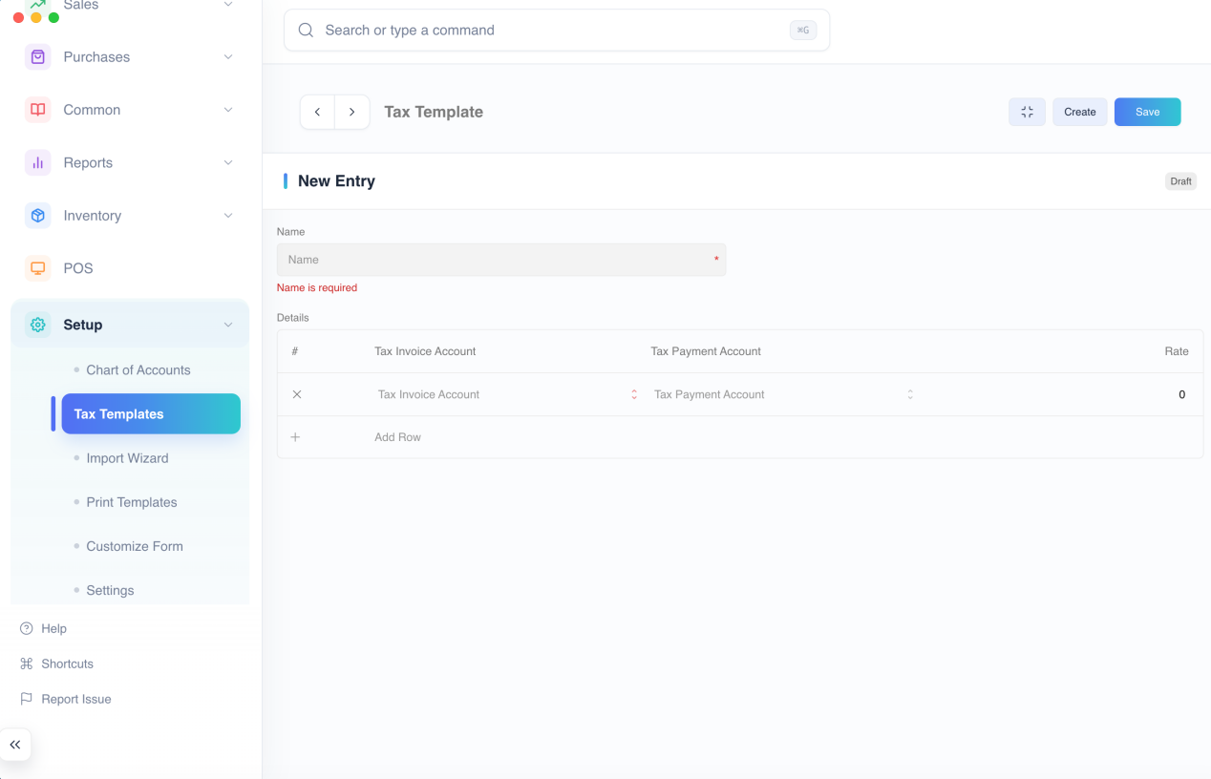
Enter the values and click the blue Save button. The entry will now be made and can be used in transactions.

Duplicating an Entry
To create the duplicate of an entry, click on the ... menu button and select Duplicate.
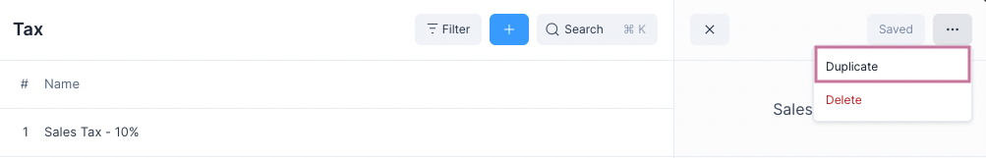
This will create a Draft entry, i.e. it is not yet saved, you can change the values and click on Save.
After the entry has been Saved you can use it in transactions.

Deleting an Entry
To delete an entry, click on the ... menu button and select Delete.
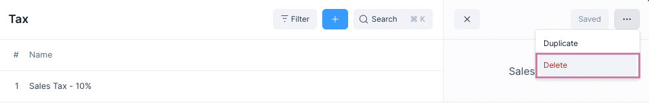
::: warning Entry Deletion Entries used in transactions cannot be deleted.
To delete these entries the Transactions where they are used will have to be deleted first. :::
Now that you know the basics of entries you can learn about specific types of entries.

Items
​

​
Item is term used by Nirolite for anything that is purchased or sold using a Sales or Purchase Invoice.
An Item is classified by what purpose it's used for.
# | For | Name | Usage | Navigation
1 | Sales | Sales Items | Sales Invoices | Sales > Sales Items
2 | Purchases | Purchase Items | Purchase Invoices | Purchases > Purchase Items
3 | Both | Common Items | Sales and Purchase Invoices | Common > Common Items
Usage Make sure that you create the Item under the correct Navigation as this cannot be changed after creation.

Item Fields
When creating a new Item the following fields are displayed:
- Item Image: an image to identify the Item by.
- Item Name: a name to identify the Item by, each Item should have a unique name.
- Item Code: a unique identifier assigned to each Item for easy tracking, reference, and differentiation.
- Item Group: a category or classification under which the Item is grouped for better organization and reporting.
- Purpose: specifies whether the Item is meant for Sales, Purchases, or Both.
- Type: indicates whether the Item is a Product or a Service.
- Unit Type: base unit of the Item to which the rate is applied
- Rate: base cost of an Item, this can be changed in the invoice.
- Description: textual description of what the Item is.
- Sales Acc.: the income account that is credited when the Item is sold.
- Purchase Acc.: the expense account that is debited when the Item is purchased.
- Tax: tax applied on the Item when making an invoice, this can be changed in the invoice.
- HSN/SAC: the HSN/SAC code that is used for classifying Items.
- Barcode: a machine-readable code used to quickly identify and scan the Item in transactions.
- Track Inventory: enables stock level monitoring for the Item to maintain accurate inventory records.
- Has Batch: specifies whether the Item is managed in batches for tracking manufacturing or expiry details.
- UOM Conversions: defines conversion rates between the Item’s base unit and other units of measure.

Customize Columns
When the Customize Columns feature is enabled in system settings, a “Customize Columns” button appears in each list view. Clicking this button opens the Column Selector Modal, which allows users to choose which columns are shown in the list. The modal provides a simple and interactive way to personalize data views through checkboxes and drag-and-drop actions.
Inside the modal, users see two sections — Displayed Fields and Available Fields. Displayed Fields show the columns that are currently visible in the list view, while Available Fields contain other fields that can be added. Users can easily reorder displayed columns by dragging them, remove columns by unchecking them or dragging them out, and add new columns by checking or dragging them from the Available Fields section. Required fields are protected from being removed, and hidden or table-type fields are excluded automatically. Once the desired columns are selected and arranged, clicking the Save button applies the changes and updates the list view accordingly.
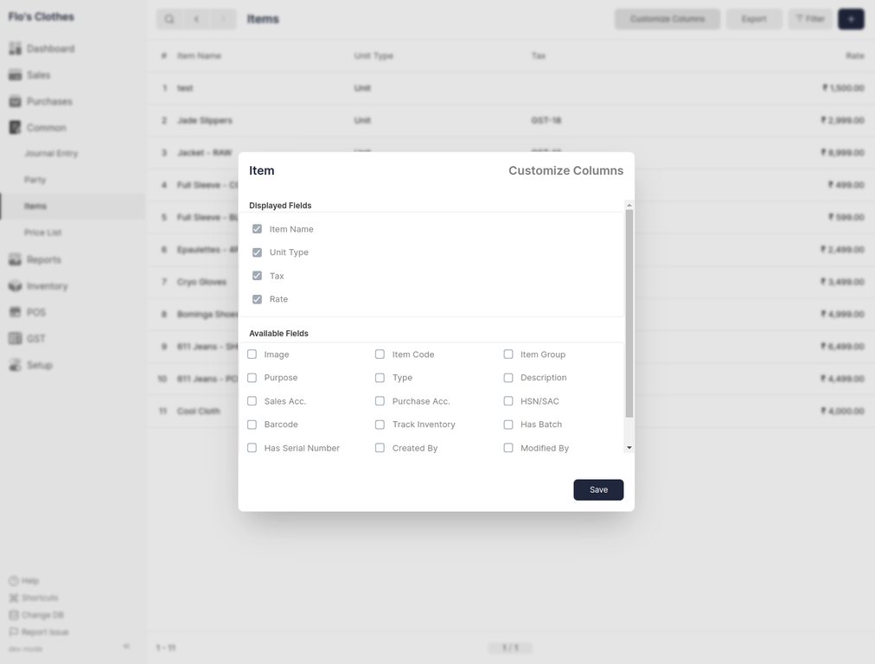

Party
​

​
Party is a term used in Nirolite for any entity to whom a Sale or from whom a Purchase is made.
A Party is classified by their Role it's used for.
# | Role | Name | Invoice | Navigation
1 | Customer | Customer | Sales Invoices | Sales > Customers
2 | Supplier | Supplier | Purchase Invoices | Purchases > Suppliers
3 | Both | Party | Sales and Purchase Invoices | Common > Party
::: warning Usage Make sure that you create the Party under the correct Navigation as this cannot be changed after creation. :::

Party Fields
- Party Image: an image to identify the Party by.
- Party Name: a name to identify the Party by, each Party should have a unique name.
- Email: the Party's email address that may be displayed when printing the invoice.
- Phone: the Party's phone number that may be displayed when printing the invoice.
- Address: the Party's address that may be displayed when printing the invoice.
- Default Account: default account that may be credited or debited when a transaction involving the part is made.
- Currency: the currency in which to create the invoice for the Party.
- Role: the role of the Party, whether they are a Customer, Supplier or Both.

Recent Invoices
The Party Quick Edit Form has a Recent Invoices widget. This shows the last three invoices made for a Party.
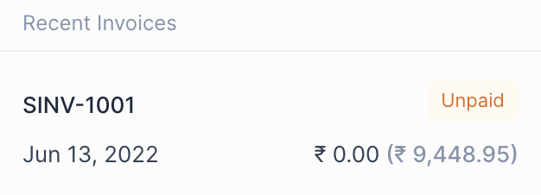
Each row shows the following information
- Invoice Name
- Invoice Status
- Date
- Paid Amount
- Outstanding Amount
Clicking on a row will take you to the Invoice from where Payments can be made.

Taxes
​

​
To calculate the amount of tax on an Item's purchase or sale, a Tax entry has to be selected on the invoice row.
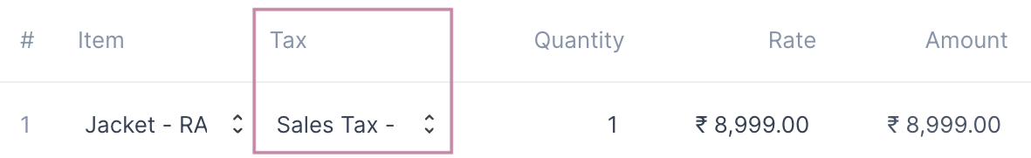
::: tip Auto Set Tax If the Tax has been set on the Item then it will be auto set in the invoice row. :::
Tax entries can be made from the Tax page: Setup > Taxes

Tax Fields
A Tax entry has just two fields
- Tax Name: a unique name to identify the tax by.
- Tax Detail: a table where the Tax account along with the Tax rate is set.
::: info Tax Detail Tax Detail is a table as a single tax can have multiple components each with a separate account and rate. :::

Price List
​

​
Using Price List, you can keep track of multiple Item Prices for sales and purchase.
An Item can by priced differently depending on whether it is for sale or purchase, if it is discount season, etc.
A Price List helps by grouping multiple item prices under a single entry. You can then select this entry when making a Sales or a Purchase Invoice, and when an item is selected its rate will be fetched from the Price list.
To use Price Lists you need to first enable them.

Enable Price List
The Price List feature needs to be enabled first by checking the Enable Price List option in the General Settings.
To navigate: Setup > Settings > General Tab
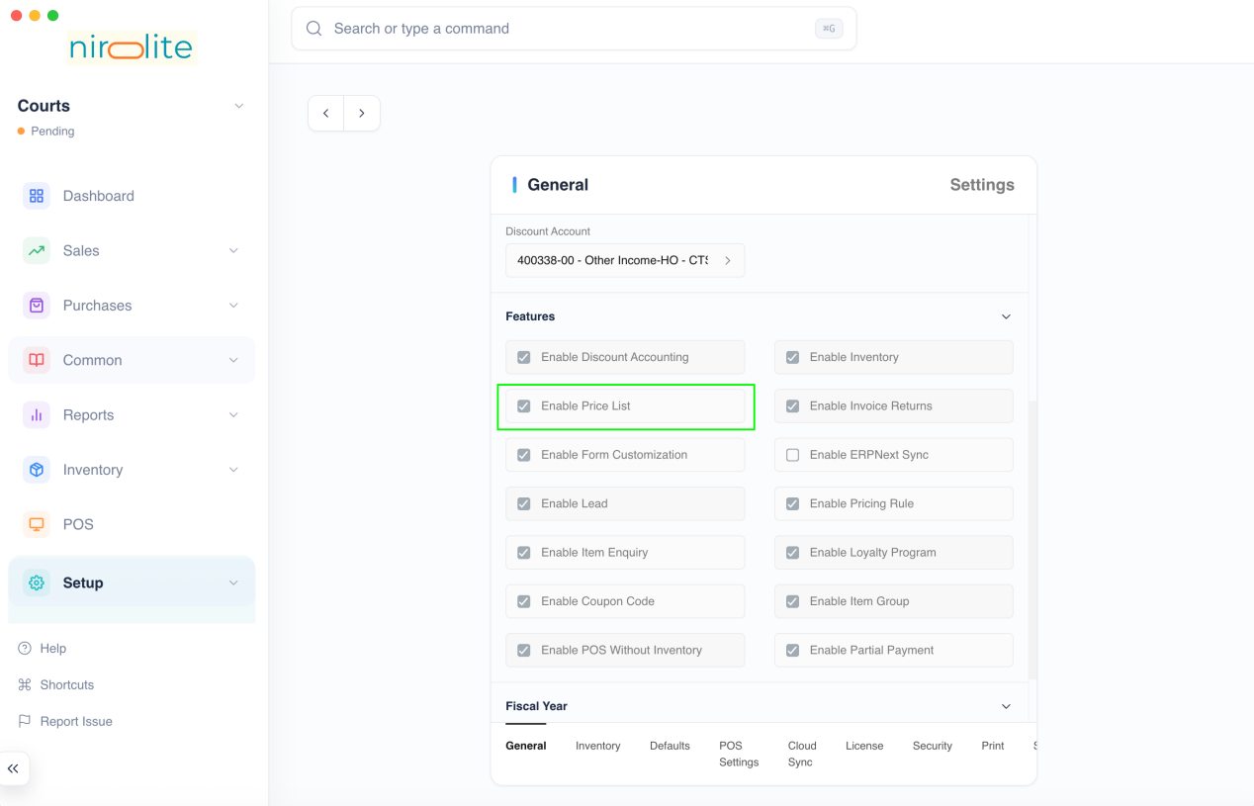

Create a Price List
To create a Price Lists, go to:Common > Price List. And then click on the blue + button to open a new Price List creation form.
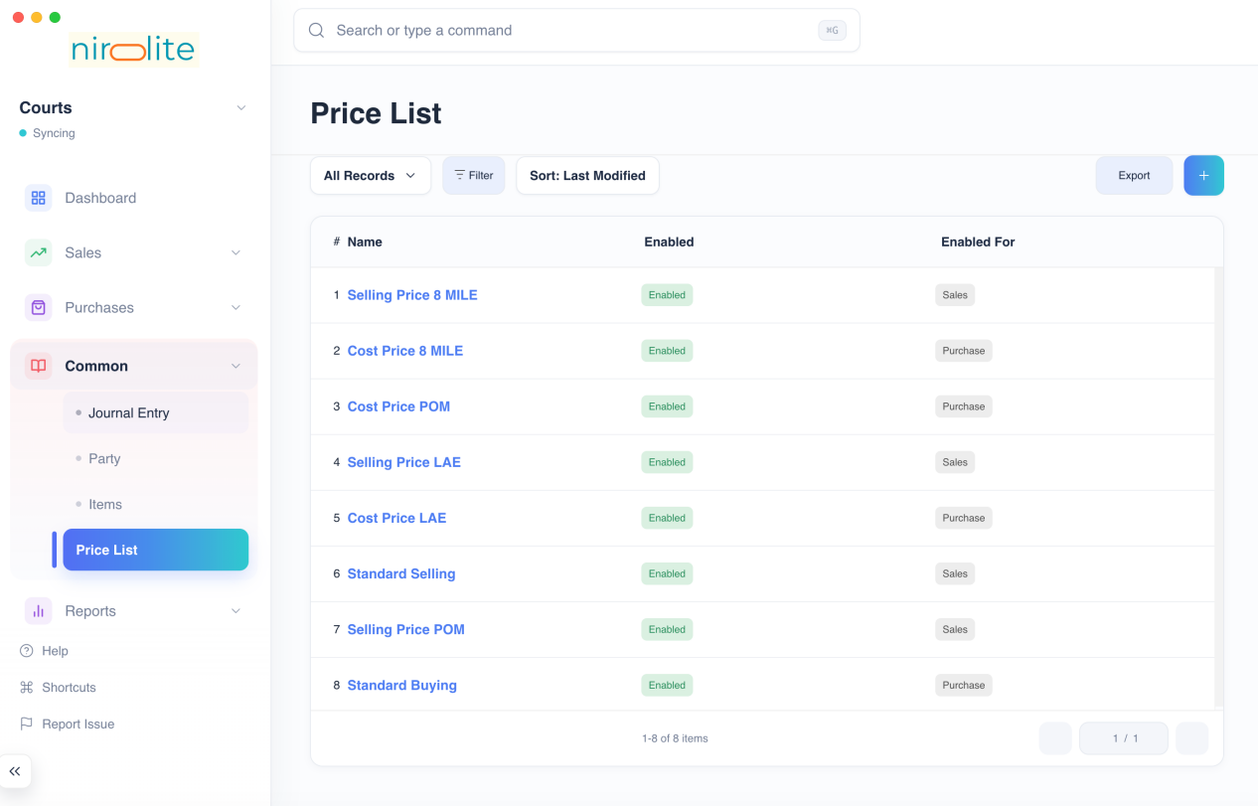
Add Item Prices to your price list, when done click on the Save button.
Price List Fields:
- Is Price List Enabled: enables the Price List, if disabled it cannot be used.
- For Sales: if enabled, the Price List can be selected in Sales Invoices.
- For Purchases: if enabled, the Price List can be selected in Purchase Invoices.
:::tip Multiple Prices
You can add multiple prices for an Item in the Price List. When fetching the price from the Price List, the first Item Price with a matching Unit Type will be selected. :::

Setting a Price List
To use a Price List, ou need to select Price List in the Sales or Purchase Invoice form.
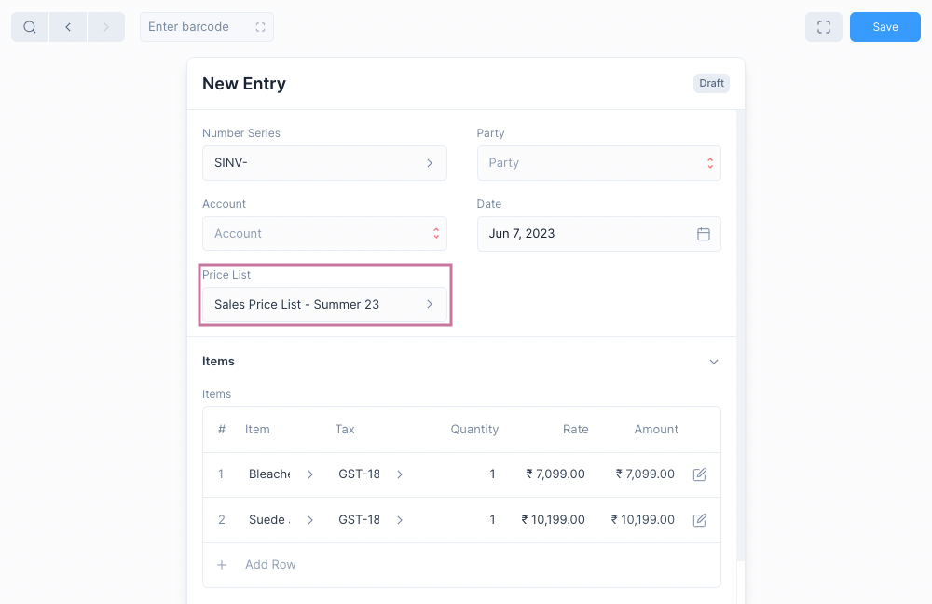
Once this is done, when a new item is selected it's price will be fetched from the selected Price List.

Pricing Rule
​

​
Pricing rules allow you to offer flexible discounts and prices based on various criteria, making your sales promotions more targeted and impactful.
Common Use Cases:
- Quantity Discounts: Offer a discount (percentage or amount) on items when a certain quantity is purchased (e.g., 10% off for buying 5 or more items).
- Buy-One-Get-One (BOGO) Offers: Give away a free item or offer a significant discount on a second item when a specific item is purchased.
- Tiered Pricing: Set different price levels for items based on the total order value (e.g., offer a lower price per unit when customers spend above a certain amount).
- Early Bird Discounts: Provide a discount for orders placed before a specific date.

Enable Pricing Rules
- Go to Setup > Settings.
- Navigate to the Features section.
- Check the boxes for the Enable Discount Accounting and Enable Pricing Rule.
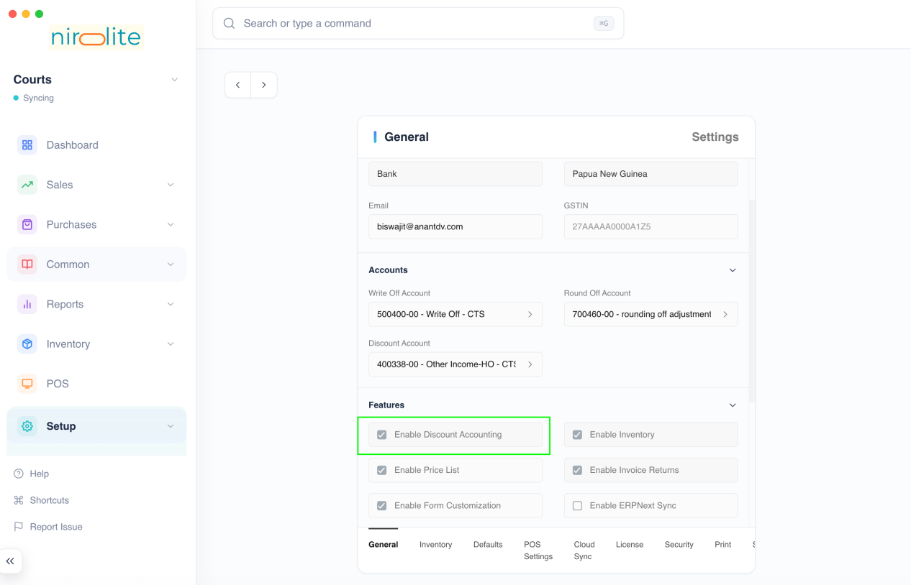

Creating a Pricing Rule
- Go to Common > Pricing Rule.
- Click the + button to create a new rule.

Pricing Rule Fields
- Is Pricing Rule Enabled: Check this box to activate the rule.
- Items: Select the specific items or item groups to which the rule applies. Leave blank to apply to all items.
- Price Discount Type: Choose the type of discount you want to offer:
  - Rate: Set a fixed discount amount (e.g., $5 off).
  - Discount Percentage: Apply a percentage discount (e.g., 10% off).
  - Discount Amount: Offer a specific discount per unit (e.g., $1 discount per item).
- Free Item: Select the item you want to offer for free or at a discount.
- Quantity: Enter the number of free items to be given with the purchase.
- UOM: Specify the unit of measurement for the free item.
- Rate: If offering a discount on the free item, enter the discounted price.
- Round Free Item Quantity:
  - Rounding Method: Choose how to handle fractional quantities of free items:
    - Floor: Round down to the nearest whole number (e.g., 10.1 free items becomes 10).
    - Round: Round to the nearest whole number (e.g., 10.1 free items becomes 10, 10.9 becomes 11).
    - Ceil: Round up to the nearest whole number (e.g., 10.1 free items becomes 11).
- Is Recursive: Enable this option for BOGO offers where buying multiple qualifying items triggers the offer multiple times.
- Recurse Every: (Applicable only if "Is Recursive" is enabled) Set the number of items for which the BOGO offers repeats (e.g., buy 2, get 1 free repeat every 2 purchases).
- Min Qty: Minimum quantity of the specified item required to trigger the rule.
- Max Qty: Maximum quantity of the specified item to which the rule applies.
- Min Amount: Minimum order value for the rule to be applied.
- Max Amount: Maximum order value for the rule to be applied.
- Valid From: The start date for the pricing rule to be active.
- Valid Till: End date for the pricing rule to be inactive.
- Priority: Assign a number to determine the order of applying multiple pricing rules to the same item. The rule with the highest priority takes precedence.

Examples

BOGO Offer: Buy 3 Get 1

Field | Value
Discount Type | Product Discount
Quantity | 1
Rate | 0
Recurse Every | 3

Buy 2 Get 10% Discount

Field | Value
Discount Type | Price Discount
Price Discount Type | Discount Percent
Discount Percentage | 10
Min Qty (As Per Stock Unit) | 2

Coupon Code
​

​
A coupon code can be used to get a discount. To use a coupon, you must first set up a pricing rule. This rule determines the specific discount or offer associated with the coupon. When you apply the coupon, it will follow the rules you set up.
- Go to Setup > Settings.
- Navigate to the Features section.
- Check the boxes for the Enable Discount Accounting, Enable Pricing Rule, and Enable Coupon Code.
Note: Discount Accounting and Pricing Rule should be enabled to use Coupon Codes
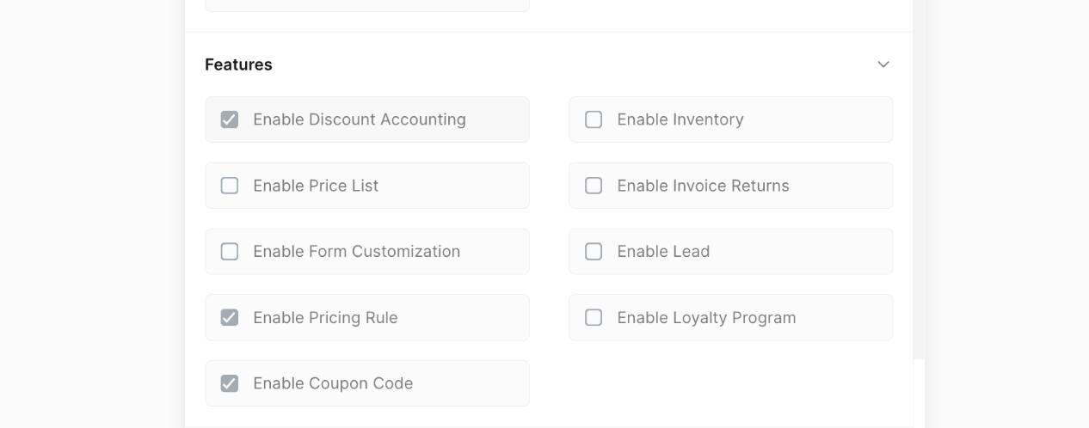
Once that is done you will have to restart Nirolite to see the Coupon Code in the sidebar.
Note: Coupon Code cannot be disabled once it has been enabled.

Creating Coupon Code
To create a Coupon Code first navigate to the Coupon Code page
Sales > Coupon Code
Then click on the + button to open the Coupon Code form.
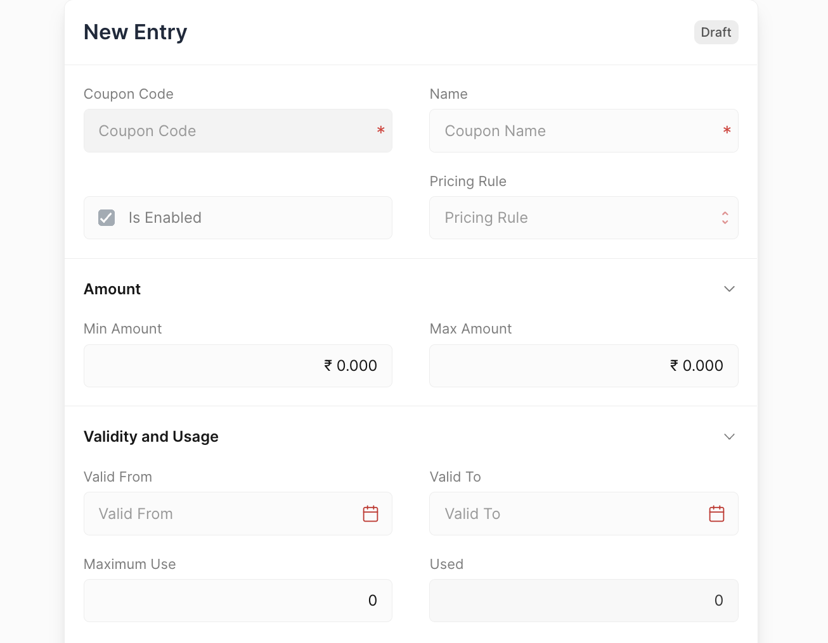
- Is Enabled: To mark the Coupon Code as active.
- Pricing Rule: Select the pricing rule that applies when a specific coupon code is used.
- Min Amount: Minimum order value for the rule to be applied.
- Max Amount: Maximum order value for the rule to be applied.
- Valid From: The start date for the pricing rule to be active.
- Valid To: End date for the pricing rule to be inactive.
- Maximum Use: Maximum use for the coupon to be applied.
- Used: Count of times the coupon has been applied.

Apply Coupon Code
You can select coupons to get discounts. The coupon will apply a discount based on the rules set for that coupon.
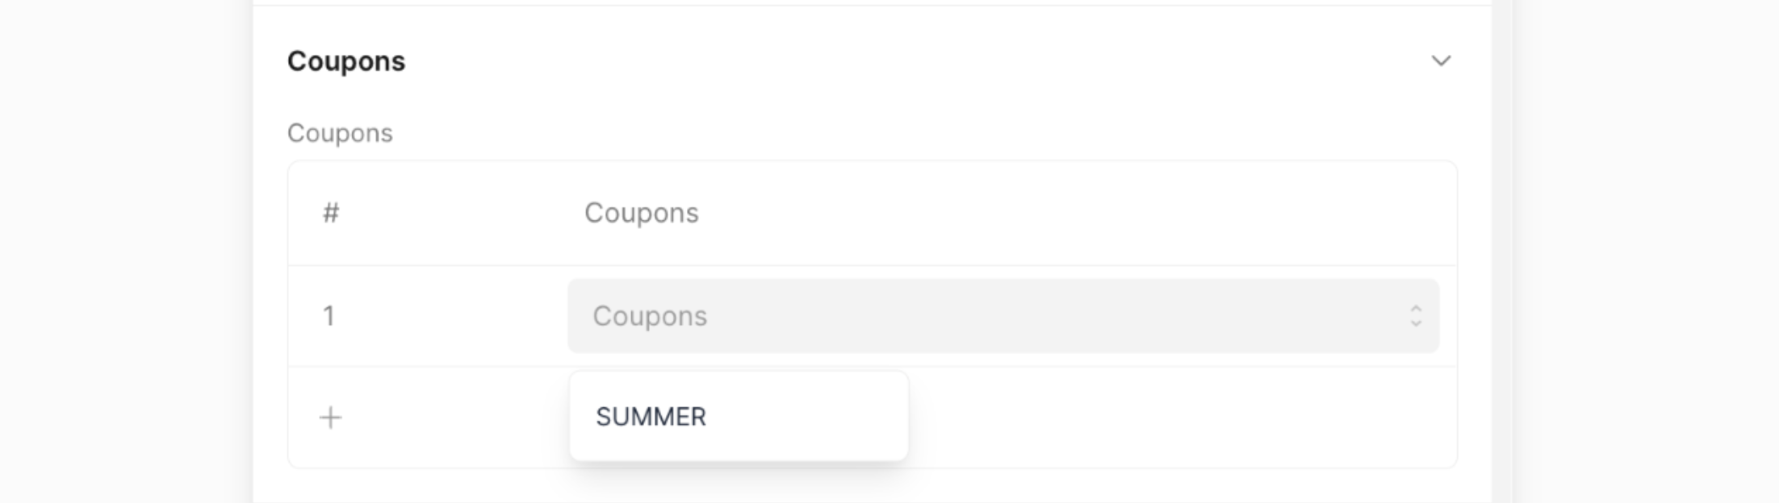
Applied Pricing rule can be viewed in the Pricing Rule Detail section.
